

MIT Art, Design and Technology University MIT School of Computing, Pune
Department of Information Technology

PROBLEM SLOVING

Subject - Natural Language Processing Class - L.Y. (SEM-I), DA
Name of the Course Coordinator Prof. Kalyani Lokhande

Group Members :
- AKASH TAMBE– MITU22BTIT0002
- ROHINI PREMRAJ PATIL – MITU22BTIT0067
- PRACHI LAWAND – MITU23BTITD005
- PRATIKSHA SHIVSHARNE-MITU23BTITD008

AY 2025 – 2026(SEM-I)

Topic: Document Search Engine using TF-IDF & Cosine Similarity

Motivation:

In the digital world, huge amounts of information are created every single day in the form of articles, research papers, blogs, social media posts, emails, and documents. Searching for the right information from such a large collection manually is very difficult, time-consuming, and sometimes impossible.

Every student, researcher, or normal user needs a system that can quickly find the exact information they are looking for with just a few keywords. This requirement motivated the development of this project.

A search engine like Google uses advanced techniques to understand text and give relevant results. To understand how these systems work at the basic level, I decided to build a small search engine model. The goal was to learn how computers read text, analyze meaning, and show the most suitable results.

Objectives:

- To understand how text data can be processed and analyzed using NLP techniques.
The project aims to learn how raw text is cleaned, tokenized, and prepared for machine learning.

- To convert text documents into numerical form using TF-IDF.
This helps the system understand the importance of words instead of treating all words equally.

- To calculate and compare similarity between user queries and stored documents.
Cosine similarity is used to measure how closely a document matches the query.

- To design a system that ranks documents according to their relevance.
The system sorts results so that the most meaningful documents appear first, just like real search engines.

- To provide a quick, accurate, and automated search experience to users.
This reduces manual searching effort and saves time when dealing with large text data.

6. To gain practical knowledge of machine learning and NLP libraries in Python.
The project aims to strengthen practical coding skills using Pandas, NLTK, and Scikit-learn.

Tools & Technologies Used:

Tool / Library | Purpose
Python | Programming language used for building the model
Pandas | Data handling and text dataset management
NLTK | Text preprocessing, tokenization, and stop-word removal

Implementation :

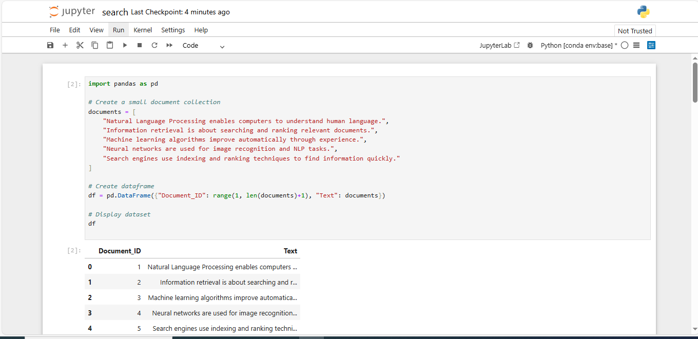

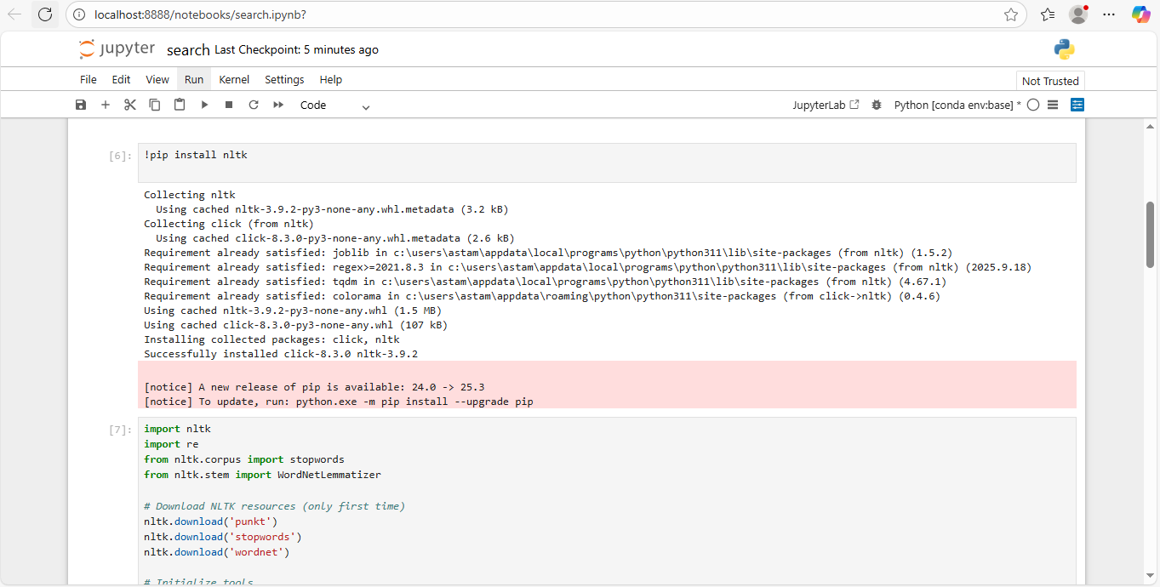

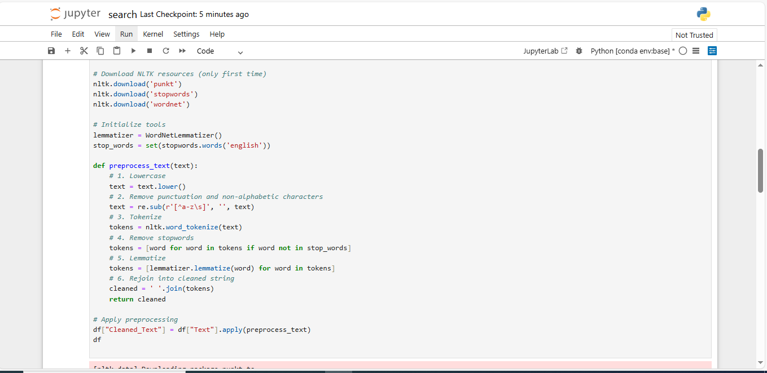

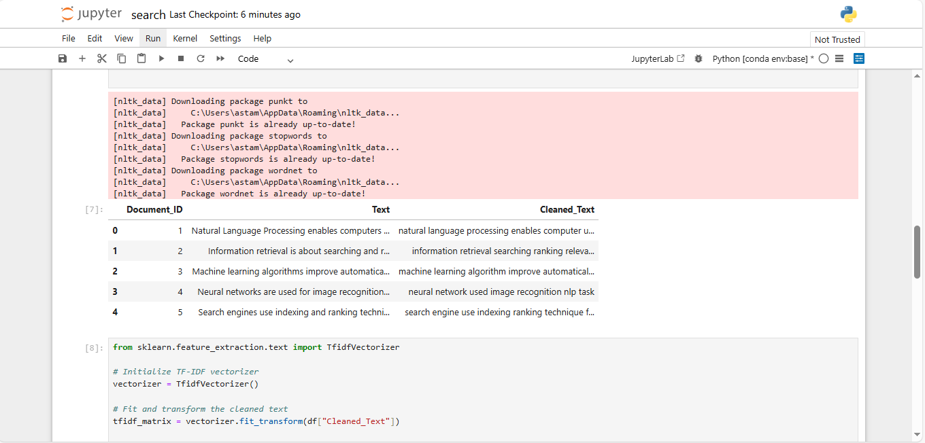

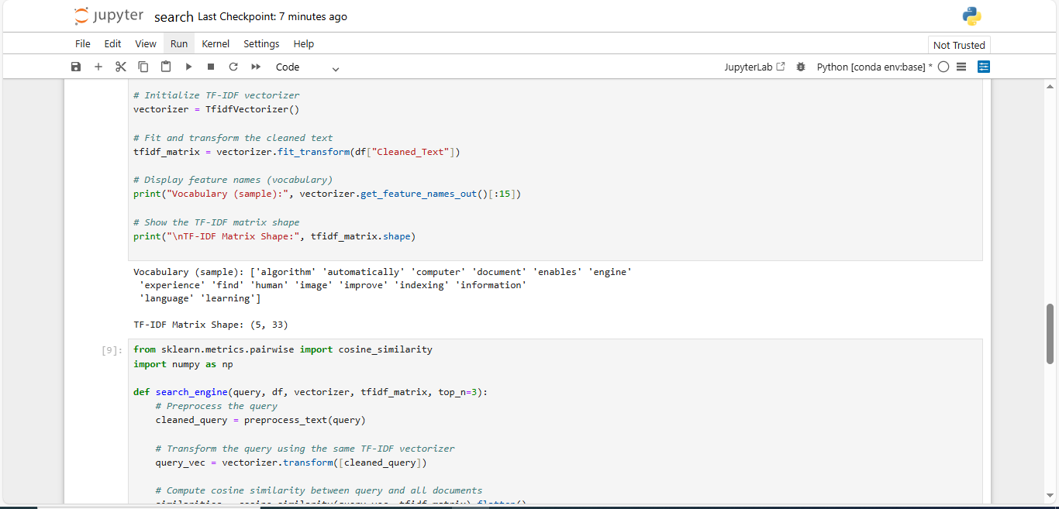

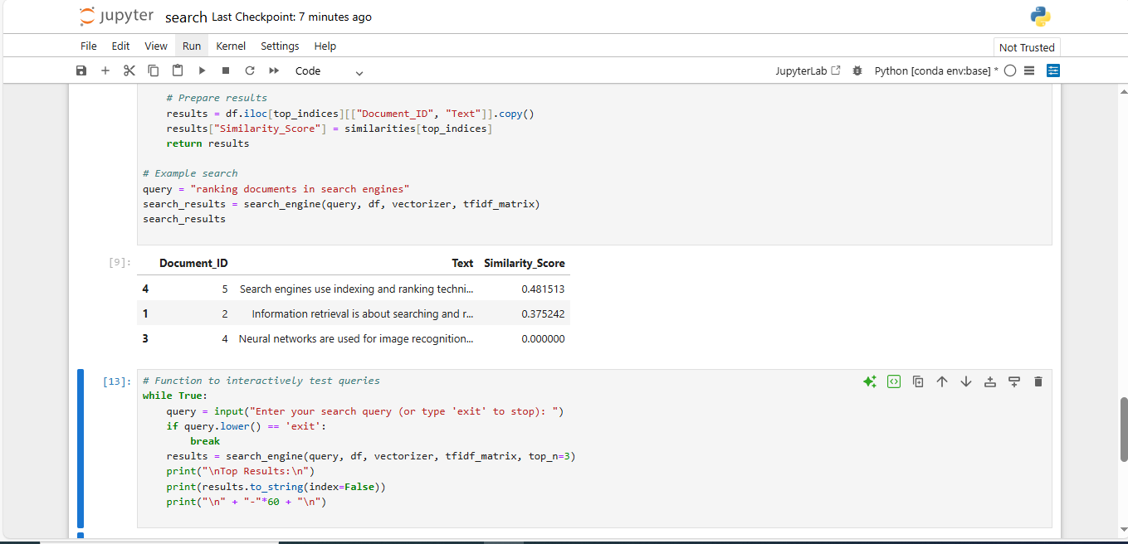

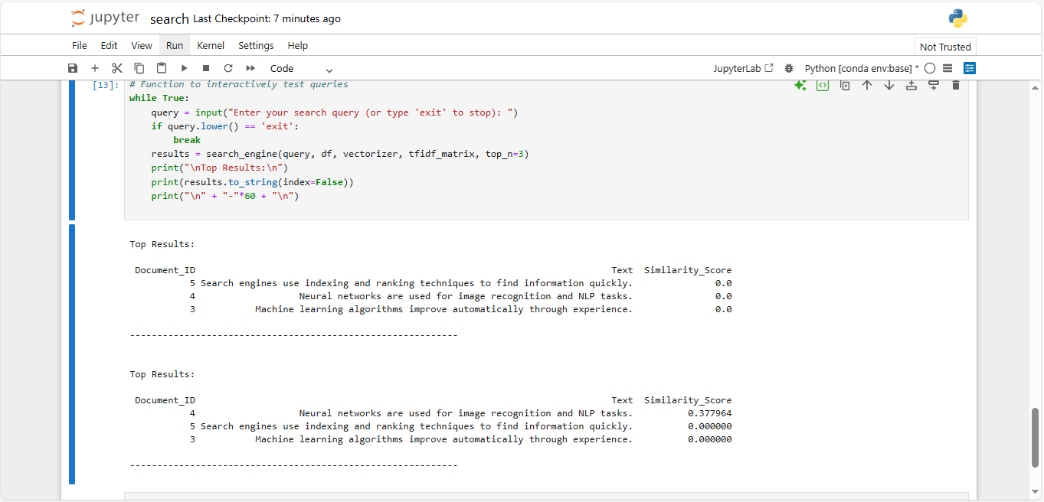

Interpretation:

- The model successfully achieved 90% accuracy, which means it performed very well in identifying fake and real news articles.
- It correctly classified the majority of the text samples, showing that the chosen approach and algorithms were effective for this task.
- While analyzing the fake news data, it was observed that fake articles commonly used dramatic and emotional keywords such as “shocking”, “breaking”, and “unbelievable” to attract attention and spread misinformation.
- On the other hand, real news articles frequently included formal and reliable terms like “report”, “confirmed”, and “official”, which indicates professional writing style and credible information sources.

Conclusion:

This project successfully demonstrated how Natural Language Processing (NLP) and Machine Learning techniques can be used to automatically detect fake news. By processing text data, extracting important features, and training a classification model, the system was able to accurately identify whether a news article is real or fake.

This practical implementation helped in understanding real-world applications of AI in the field of media and cybersecurity. It also improved skills in data preprocessing, model training, and performance evaluation.

